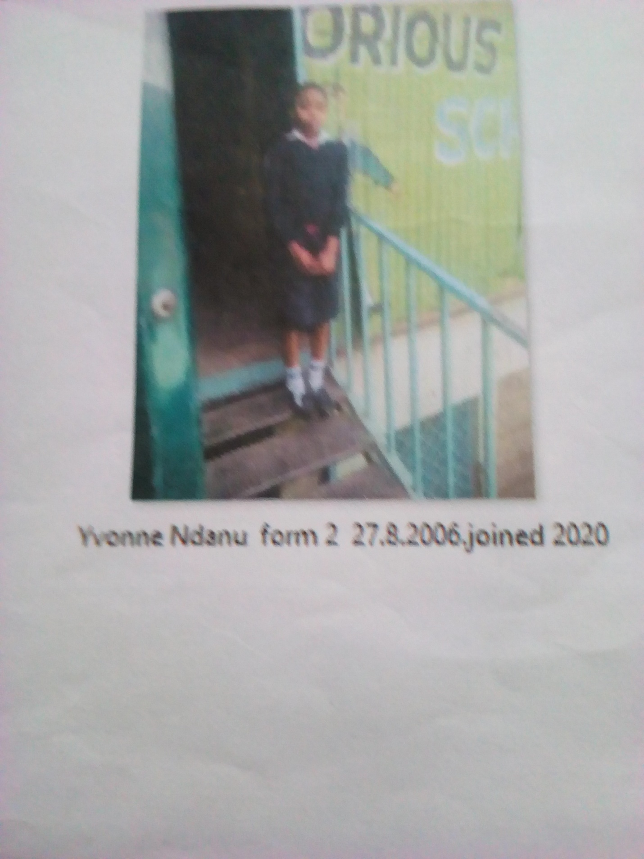
YVONE NDANU FORM 2 BORN 2006 JOINED 2020
Yvonne 15 years was enrolled in our school when he was 14 years old. Yvonne is a needy girl, rescued at night from irate boys when they attempted to rape her. She had chased away by her step mother. It happened so after her mother died and the father remarried. She sought help in school and she became accepted in school after the Director was contacted.
Thanks to the Director Mr. Boniface Mangeti who allowed Yvone in school. I am now learning in glorious at least I have a place I call home praying that one day God will help our school have good classes, toilets and enough learning materials. Thank you Michell and Brad for your support have really helped many in Mukuru

